Subject: Join us in voting YES to RENEW the Best Starts for Kids Levy!

Dear friend –

This election we have an important opportunity to give every child across King County the best start in life and the opportunity to reach their full potential!

Join organizations serving kids and families like ours, child care workers, community leaders, and neighbors in voting YES to renew Prop 1, the Best Starts for Kids Levy on your Aug. 3rd ballot.

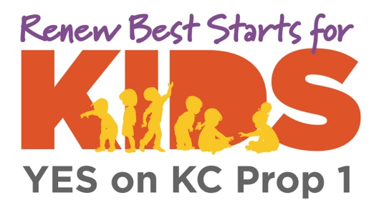

Best Starts for Kids will not only maintain, but expand current programs that support kids through homelessness prevention, access to school-based healthcare, counseling, social and emotional youth development programs, and so much more. The renewal also provides families with access to high quality childcare, and ensures that child care workers earn a living wage – essential for pandemic recovery.

The Seattle Times endorsed Prop 1 saying that, “Best Starts has made the difference in the lives of hundreds of thousands of children, young adults and families. It deserves to be renewed.”

Ballots are arriving in mailboxes this week. Be sure to vote YES on Prop 1 – it’s the top priority at the top of your ballot -- and be sure to return your ballot by Tuesday, August 3rd. Remember, you can use a Ballot Drop Box or return your ballot in a postage paid envelope.

Sincerely,

XXXXXXXX

P.S. Want to do more to support Best Starts for Kids? Check out the website to sign up to volunteer, attend a BSK event, get a yard sign, and more!

