Whole Child 2018 Conference
Trauma-Informed Somatic-Based Tools For Youth
Sun Breaths Exercise
Release palms down rotate palms outward. Inhale raising arms up, rotate palms outward exhale floating arms down. Inhale up, exhale down. Follow the rhythm of your breath.
Seated Side/Neck Stretch
1. Sit on the edge of a chair with both feet on the floor. Rest your hands in your lap. Sink both of your sitting bones into your support. Lengthen through your spine all the way up to the top of your head and down through your tailbone. Relax your thighs and sense the 3 points of your feet (center of your heel, inner and outer edge of the balls of your feet) on the ground. Begin a practice of Centering Breath.
2. Keep your spine vertical. Tip your left ear to your left shoulder. Take 3 deep breaths.
3. Extend your right arm on a low diagonal to the right. Breath into the right side of your neck. Now bring your head back to center and relax your arms with your hands in your lap.
4. Repeat on the right side.
5. Stay seated with your feet on the floor. Check that the 3 points of your feet are still connected to the ground. Interlace your hands and stretch your palms to the ceiling, lengthening your arms upward.
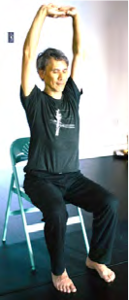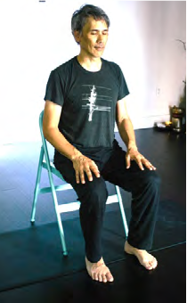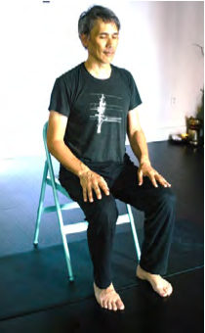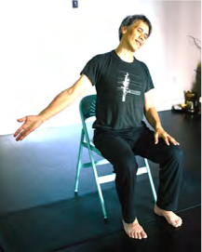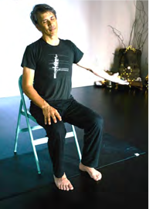

Seated Outer-Hip and Twist
1. Sit on the edge of a chair with both feet on the floor. Rest your hands in your lap. Sink both of your sitting bones into your support. Lengthen through your spine all the way up to the top of your head and down through your tailbone. Relax your thighs and sense the 3 points of your feet (center of your heel, inner and outer edge of the balls of your feet) on the ground. Begin a practice of Centering Breath.
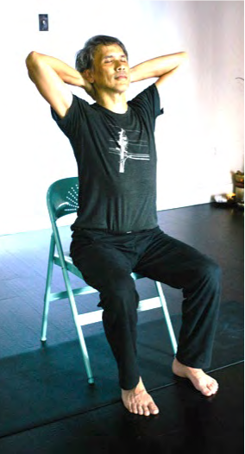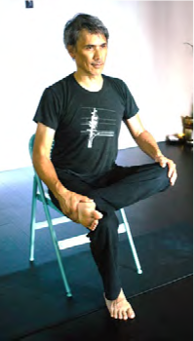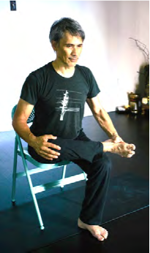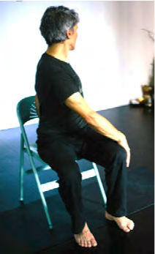
2. Keep your spine vertical. Tip your left ear to your left shoulder. Take 3 deep breaths.
3. Extend your right arm on a low diagonal to the right. Breath into the right side of your neck. Now bring your head back to center and relax your arms with your hands in your lap.
4. Repeat on the right side.
5. Stay seated with your feet on the floor. Check that the 3 points of your feet are still connected to the ground. Interlace your hands and stretch your palms to the ceiling, lengthening your arms upward.
6. Keep your hands interlaced. Cradle the back of your head with your hands. Lean your head back slightly to rest in your hands and create a very small heart lift in your chest.
7. Sit upright with both feet on the floor. Keep your pelvis steady on your chair. Take a deep breath in to lengthen your spine. On your exhale, twist to the left. Place your left hand on the chair or bed and your right hand on your outer left thigh. Take a few breaths here. On your 4th or 5th inhale return to neutral.
8. Return your spine to neutral. Relax your arms. Now cross your left ankle over your right knee. You can stay upright in your spine or begin to bow forward with a long spine until you feel a deepening of sensation in your left outer hip. Pause here for 5-10 breaths. Return to neutral with both feet on the floor.
9. Repeat with right ankle.
10. Sit in your original seat. Place your hands on the sides of the chair behind your pelvis. Keep your pelvis rooted and arch your spine to lift your chest. Imagine your hands still clasped behind your head to support your neck. Take 3 breaths. Return to neutral.
11. Place your hands on the sides of the chair behind your pelvis. Stretch your left leg forward. Keep your heel on the floor and lengthen your left leg as much as possible. Keep your hands on the chair or bed and bow forward with a long spine.
12. Repeat with right leg.
13. Bring your spine back to neutral. Keep your feet on the floor. Bow forward placing your hands on the floor or in your lap.
14. Come back up to vertical. With eyes closed (if possible) take 5 slow, deep, conscious breaths. Open your eyes and take in your environment before rising to your feet to start your day or reclining on your back for rest.
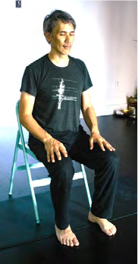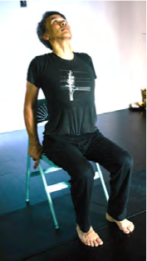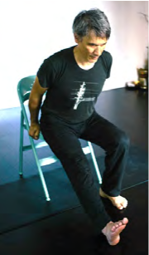
LIGHTSTREAM MEDITATION
This meditation, also known as colorstream meditation, is very simple, accessible and commonly used by some therapists working with people with trauma. It allows the student to choose certain elements of the meditation for themselves, puts them in touch with their body, and brings them into the "here and now". It can be done in Savansana or seated.
1. Begin with centering the students, bringing their awareness to their breath and/or heart center. Give them a couple minutes to tap into themselves and ask them to identify any sensations they feel with their breath or at their heart center. Remind the student that if they get distracted, or their mind wanders, they can always come back to the breath or sensations at the heart center.
2. Have the students imagine that a bright cloud is hovering high above their head. The cloud is radiating light and a calming, healing energy. They can give the light a color, any color they wish that feels comforting or has positive associations. They can also just experience the light similar to sunshine coming through a cloud. Give them a few long moments to make a choice.
3. Instruct the students to begin to breathe the light toward them, eventually pulling it into or onto the top of the head. Instruct them to take the breathe either "through" or "over" the body and use that language continually. Instruct the students to scan down each part of the body, taking the colorful light over or through the body, one part at a time, down to their toes. Remind them a couple times that the light is healing and filled with love, safety, etc.
4. Once their entire body is being shined on or through, give them a few long moments to ascribe another quality to the light, like a texture or temperature, or even a smell. Instruct them to allow the light to brighten in intensity so that it can blot out any distress.
5. Guide them back to their heart or breath and close meditation.

BODY SCAN/SELF MAP MEDITATION

PURPOSE/EFFECTS:
The Body Scan was created to bring awareness to and help you feel the many sensations that occur throughout your body.

As you begin:
- Sit or lie down on your back in a comfortable position with your eyes open or gently closed.
- Take some time to check-in with yourself, notice how you are feeling in your body and mind. This is a chance to tune into and let go of tension in parts of the body that are feeling tight– such as the jaw, neck and shoulders, or even gripping in the calves.
- Notice the parts of your body in contact with the ground/mat. Imagine softening around those areas.
- Allow everything to fade into the background but your body. Agree to meet what you find in your body with friendliness.
During the body scan:
- Try to bring an attitude of curiosity to the practice, as if you are getting to know your body for the first time.
- Feel and be aware of any and all sensations that are present, such as tingling, tightness, heat, cold, pressure, dullness, etc.
- If you do not feel any sensations in a particular region, simply observe that and move on.
- Notice if you can perceive any thoughts or emotions that come up as you move through your body. Note these thoughts and emotions, and then return to the bare physical sensations that you are experiencing.
- Imagine you're taking a tour of your body — noticing to see what's there just today. Don't visualize or move your body parts; simply pay attention and experience them, one by one.
- If you feel any pain or discomfort in parts of your body, try to explore it for even a few seconds, feeling the various aspects of the sensation(s).
- Once you have scanned a body part, let that part fade from awareness. Release it and move on to the next region of your body.

BODY SCAN:
- Start to bring your attention to your breathing
- Then start with your left foot. Feel how your heel rests on the floor/mat. Are your toes colder than the rest of your foot? If you have a sock on or a blanket over you, can you notice the texture and weight of the fabric?
- Travel up the left leg and stop along the way to scan your ankle, then the calf, the shin, the knee and the thigh until you reach your left hip.
- Cross over to the other side, and start with your right foot, and then travel up the right leg.
- Bring your attention to your pelvic region and buttocks.
- Then travel to your stomach and the organs in your abdominal region, low back, and upper back, including the shoulder blades.
- Now bring your awareness to your chest and ribcage, heart, and lungs.
- Notice both hands and then move up the arms until you finish with the shoulders.
- Move on to your neck and throat, jaw, mouth (teeth, tongue, lips) and travel to your nose, eyes, forehead, and ears.
- Then bring your attention to your skull and scalp.
- Finally, become aware of the whole body and rest for a few minutes in this expansive awareness.

CONNECTING
- After you scan the head, feel the entire body. Feel your head connected to your neck, your neck connected to your torso, the torso connected to the arms, and the torso connected to your legs and feet.
- Finally, feel the skin around the whole body. Pay attention to the sensations on your skin (texture, pressure, temperature)

BACKGROUND
The Body Scan is a variation of a Burmese Vipassana meditation practice that involves scanning the body for physical sensations. This meditation is also done in various yoga practices. The Body Scan is used in Mindfulness-Based Stress Reduction (MBSR), created by Jon Kabat-Zinn, Ph.D.

CAUTION
If you notice intense fear or overwhelmingly strong emotions related to a particular part of the body, please discontinue the practice.

Adapted from:
Body Scan Meditation. Retrieved from: https://sites.google.com/site/psychospiritualtools/Home/meditation-practices/body-scan-meditation
Kabatt-Zin, J. (2005). Coming to our Senses. New York, NY: Hyperion Books.
Valentine, V. (2007, February 28). A Crash Course in Body Scan Meditation. National Public Radio. Retrieved from: http://www.npr.org/templates/story/story.php?storyId=7650123

